Practical 3 omsai\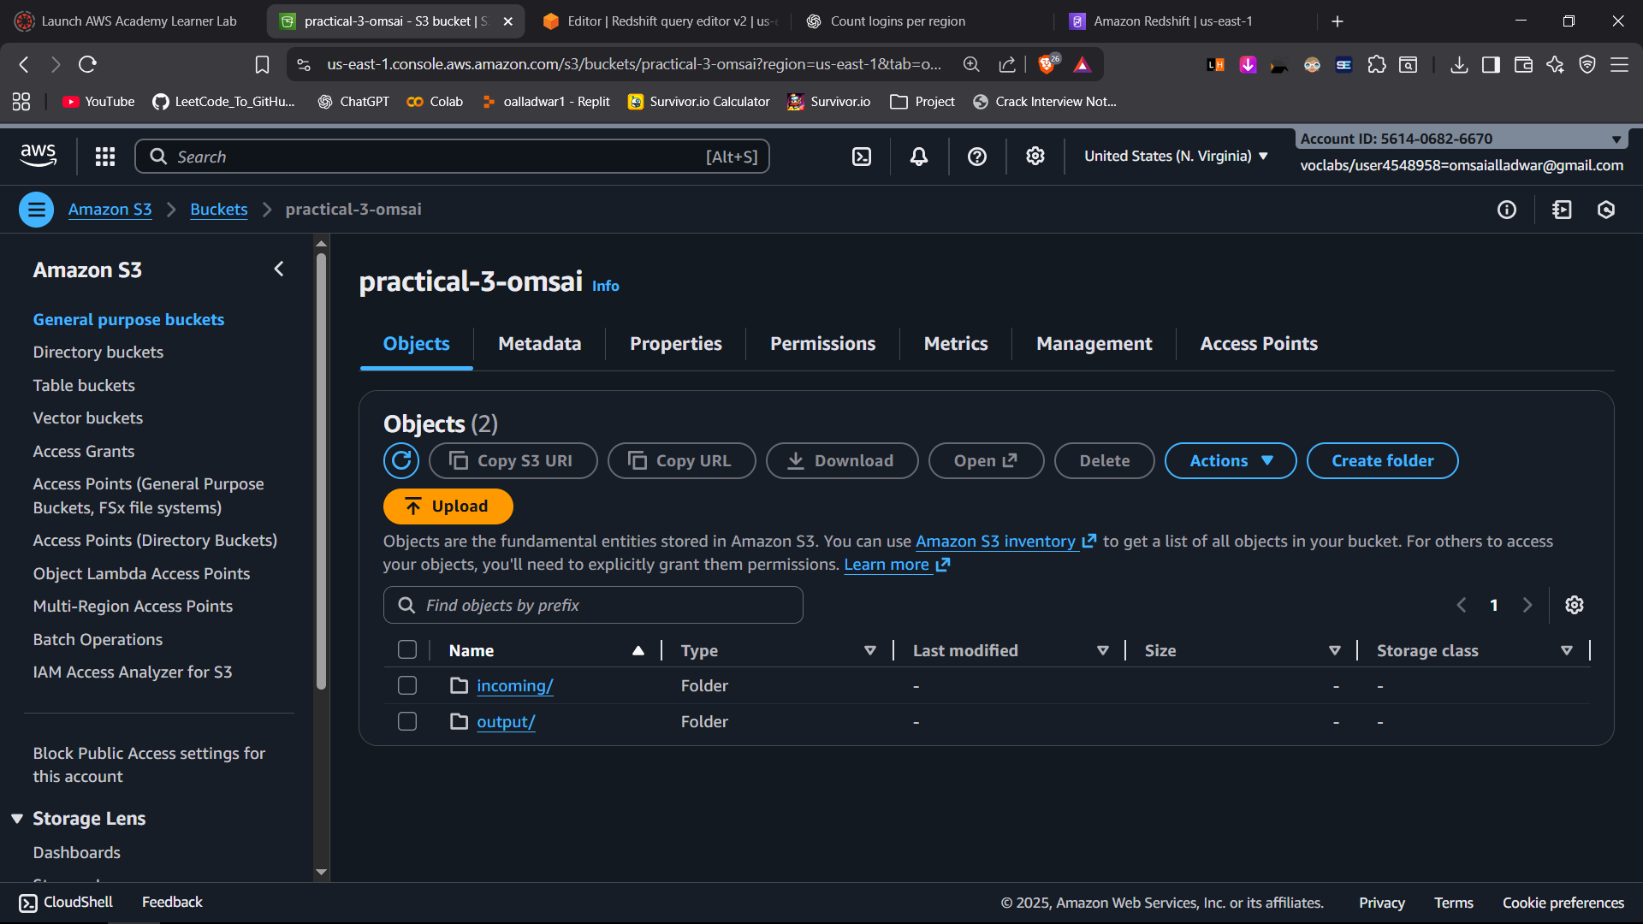
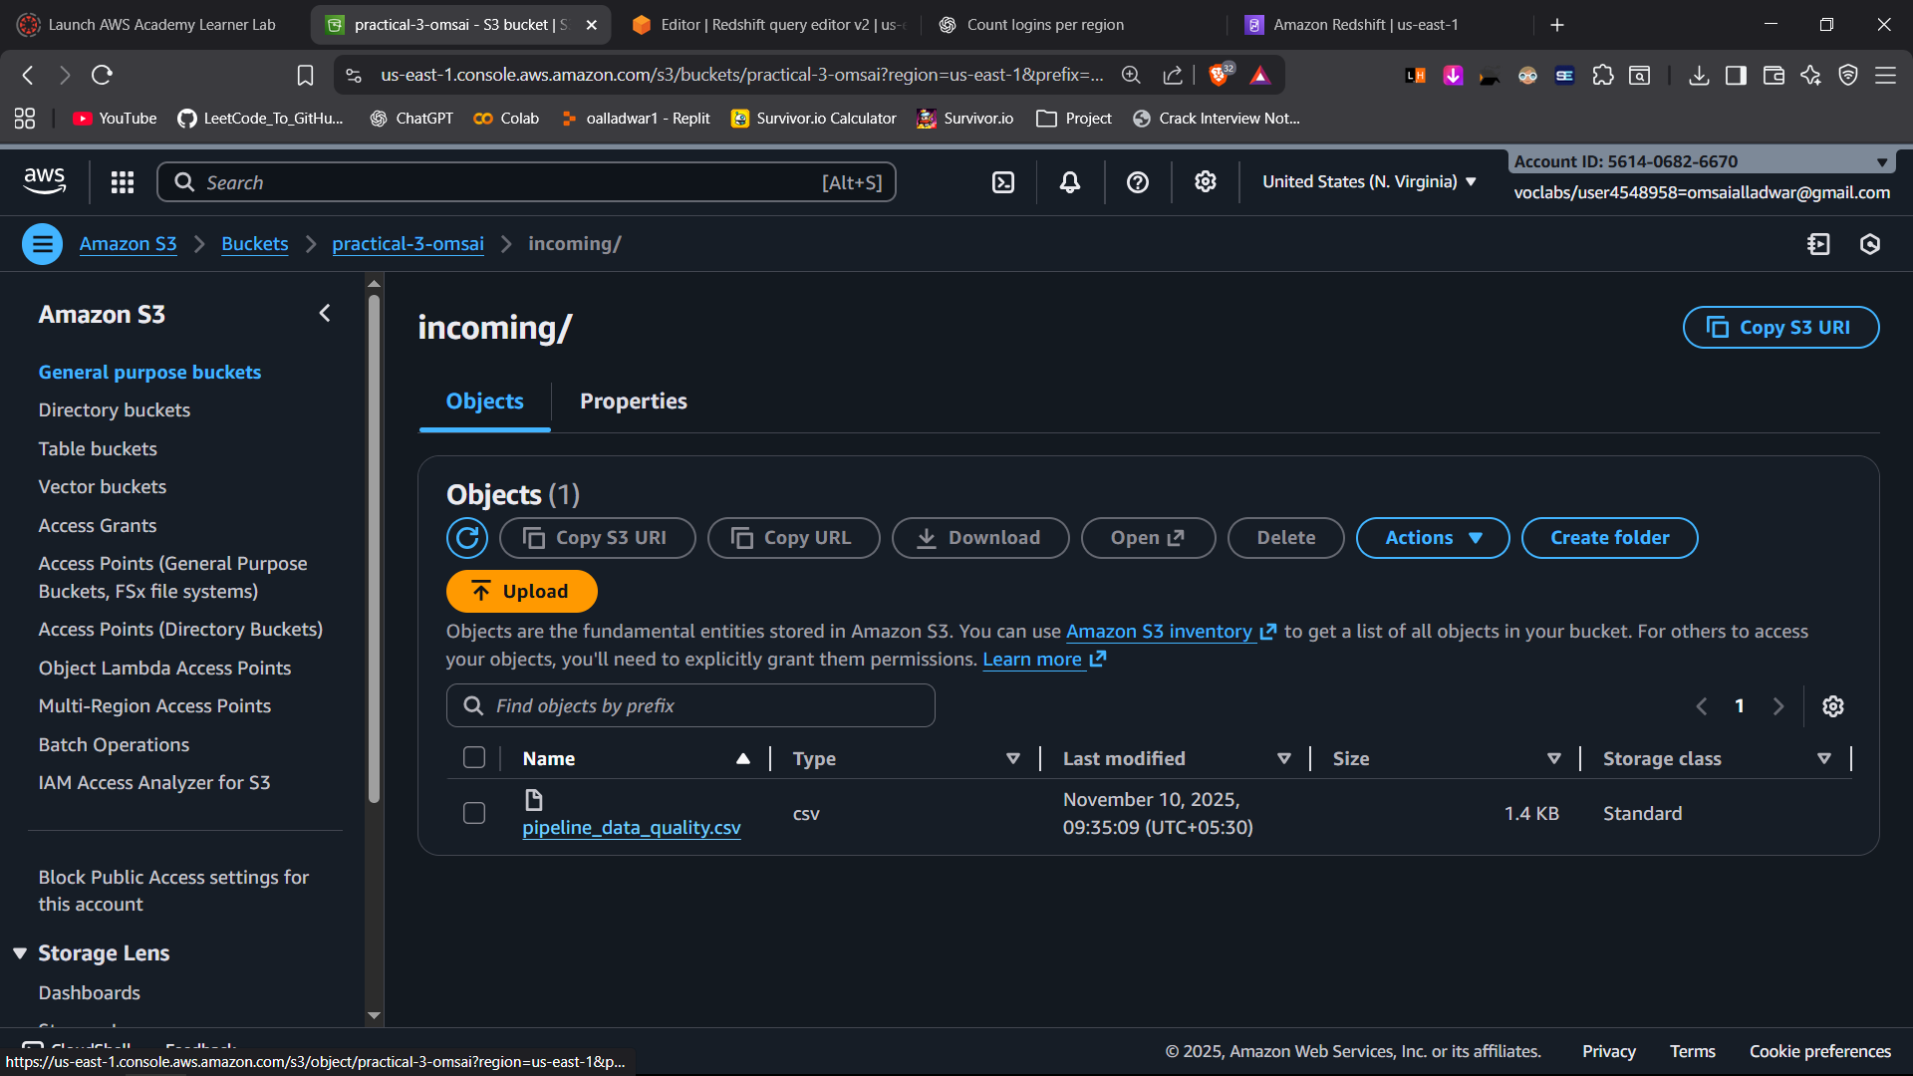

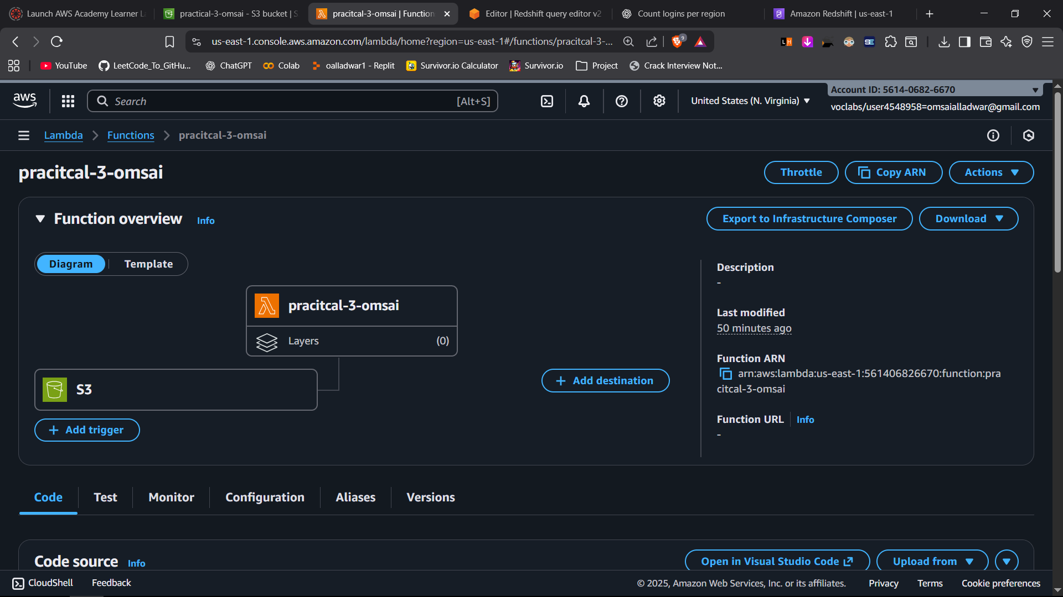
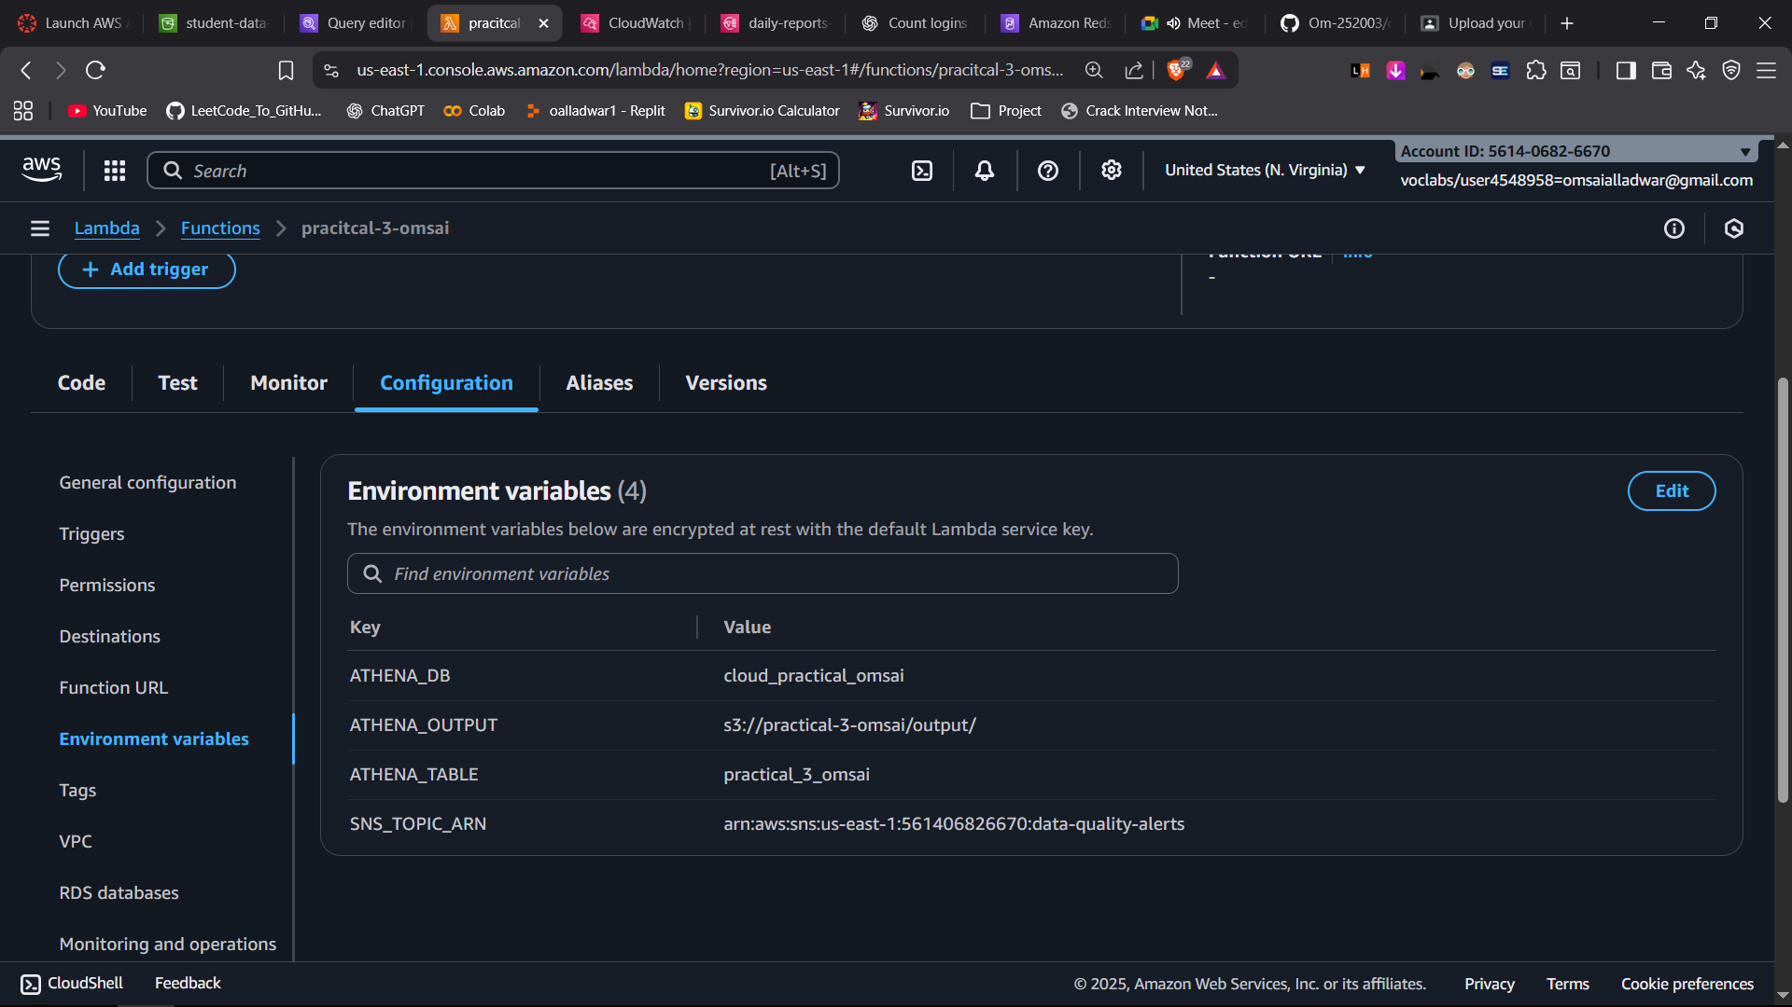
import os
import time
import json
import logging
import boto3
from botocore.exceptions import ClientError

logger = logging.getLogger()
logger.setLevel(logging.INFO)

athena = boto3.client('athena')
sns = boto3.client('sns')
cloudwatch = boto3.client('cloudwatch')

ATHENA_DB = os.environ['ATHENA_DB']
ATHENA_TABLE = os.environ['ATHENA_TABLE']
ATHENA_OUTPUT = os.environ['ATHENA_OUTPUT']
ATHENA_WORKGROUP = os.environ.get('ATHENA_WORKGROUP', 'primary')
SNS_TOPIC_ARN = os.environ['SNS_TOPIC_ARN']

# The validation query: bad if order_id missing/blank or price negative
VALIDATION_SQL = f"""
SELECT COUNT(*) AS bad_count
FROM {ATHENA_DB}.{ATHENA_TABLE}
WHERE
order_id IS NULL OR trim(order_id) = ''
OR price < 0
"""

def start_athena_query(query):
return athena.start_query_execution(
QueryString=query,
QueryExecutionContext={"Database": ATHENA_DB},
WorkGroup=ATHENA_WORKGROUP,
ResultConfiguration={"OutputLocation": ATHENA_OUTPUT}
)['QueryExecutionId']

def wait_for_query(qid, poll_seconds=2, timeout_seconds=120):
start = time.time()
while True:
resp = athena.get_query_execution(QueryExecutionId=qid)
state = resp['QueryExecution']['Status']['State']
if state in ('SUCCEEDED', 'FAILED', 'CANCELLED'):
return state, resp
if time.time() - start > timeout_seconds:
raise TimeoutError(f"Athena query {qid} timed out")
time.sleep(poll_seconds)

def fetch_single_count(qid):
res = athena.get_query_results(QueryExecutionId=qid)
rows = res.get('ResultSet', {}).get('Rows', [])
# Rows[0] is header; Rows[1] has the count if succeeded
if len(rows) < 2:
return 0
count_str = rows[1]['Data'][0]['VarCharValue']
try:
return int(count_str)
except ValueError:
logger.warning("Unexpected count value: %s", count_str)
return 0

def publish_alert(bad_count, s3_bucket, s3_key):
subject = "Daily Data Quality Alert: bad rows detected"
message = (
"Data Quality Check Failed\n\n"
f"Bad rows count: {bad_count}\n"
f"S3 Trigger: s3://{s3_bucket}/{s3_key}\n"
f"Athena Table: {ATHENA_DB}.{ATHENA_TABLE}\n\n"
"Criteria:\n"
"- missing/blank order_id\n"
"- negative price\n"
)
sns.publish(TopicArn=SNS_TOPIC_ARN, Subject=subject, Message=message)

def put_metrics(bad_count, duration_ms):
# Custom CloudWatch metrics for dashboards/alarms
cloudwatch.put_metric_data(
Namespace="DailyDataQuality",
MetricData=[
{
"MetricName": "BadRecordCount",
"Unit": "Count",
"Value": bad_count
},
{
"MetricName": "ExecutionDuration",
"Unit": "Milliseconds",
"Value": duration_ms
}
]
)

def lambda_handler(event, context):
# Grab triggering object for logging context
record = event["Records"][0]
s3_bucket = record["s3"]["bucket"]["name"]
s3_key = record["s3"]["object"]["key"]
logger.info("Triggered by: s3://%s/%s", s3_bucket, s3_key)

t0 = time.time()
try:
qid = start_athena_query(VALIDATION_SQL)
logger.info("Started Athena query: %s", qid)

state, exec_resp = wait_for_query(qid)
logger.info("Athena query finished with state: %s", state)

if state != "SUCCEEDED":
reason = exec_resp['QueryExecution']['Status'].get('StateChangeReason', 'unknown')
logger.error("Athena query failed/cancelled: %s", reason)
# Optionally alert on failure too
publish_alert(bad_count=-1, s3_bucket=s3_bucket, s3_key=s3_key)
raise RuntimeError(f"Athena query state: {state}, reason: {reason}")

bad_count = fetch_single_count(qid)
logger.info("Bad rows found: %d", bad_count)

# Push metrics
duration_ms = int((time.time() - t0) * 1000)
put_metrics(bad_count, duration_ms)

# Alert if any issues
if bad_count > 0:
publish_alert(bad_count, s3_bucket, s3_key)
logger.info("Alert published to SNS: %s", SNS_TOPIC_ARN)
else:
logger.info("No bad rows. No alert sent.")

return {"bad_count": bad_count, "query_id": qid}

except ClientError as e:
logger.exception("AWS ClientError: %s", e)
raise
except Exception as e:
logger.exception("Unhandled error: %s", e)
raise

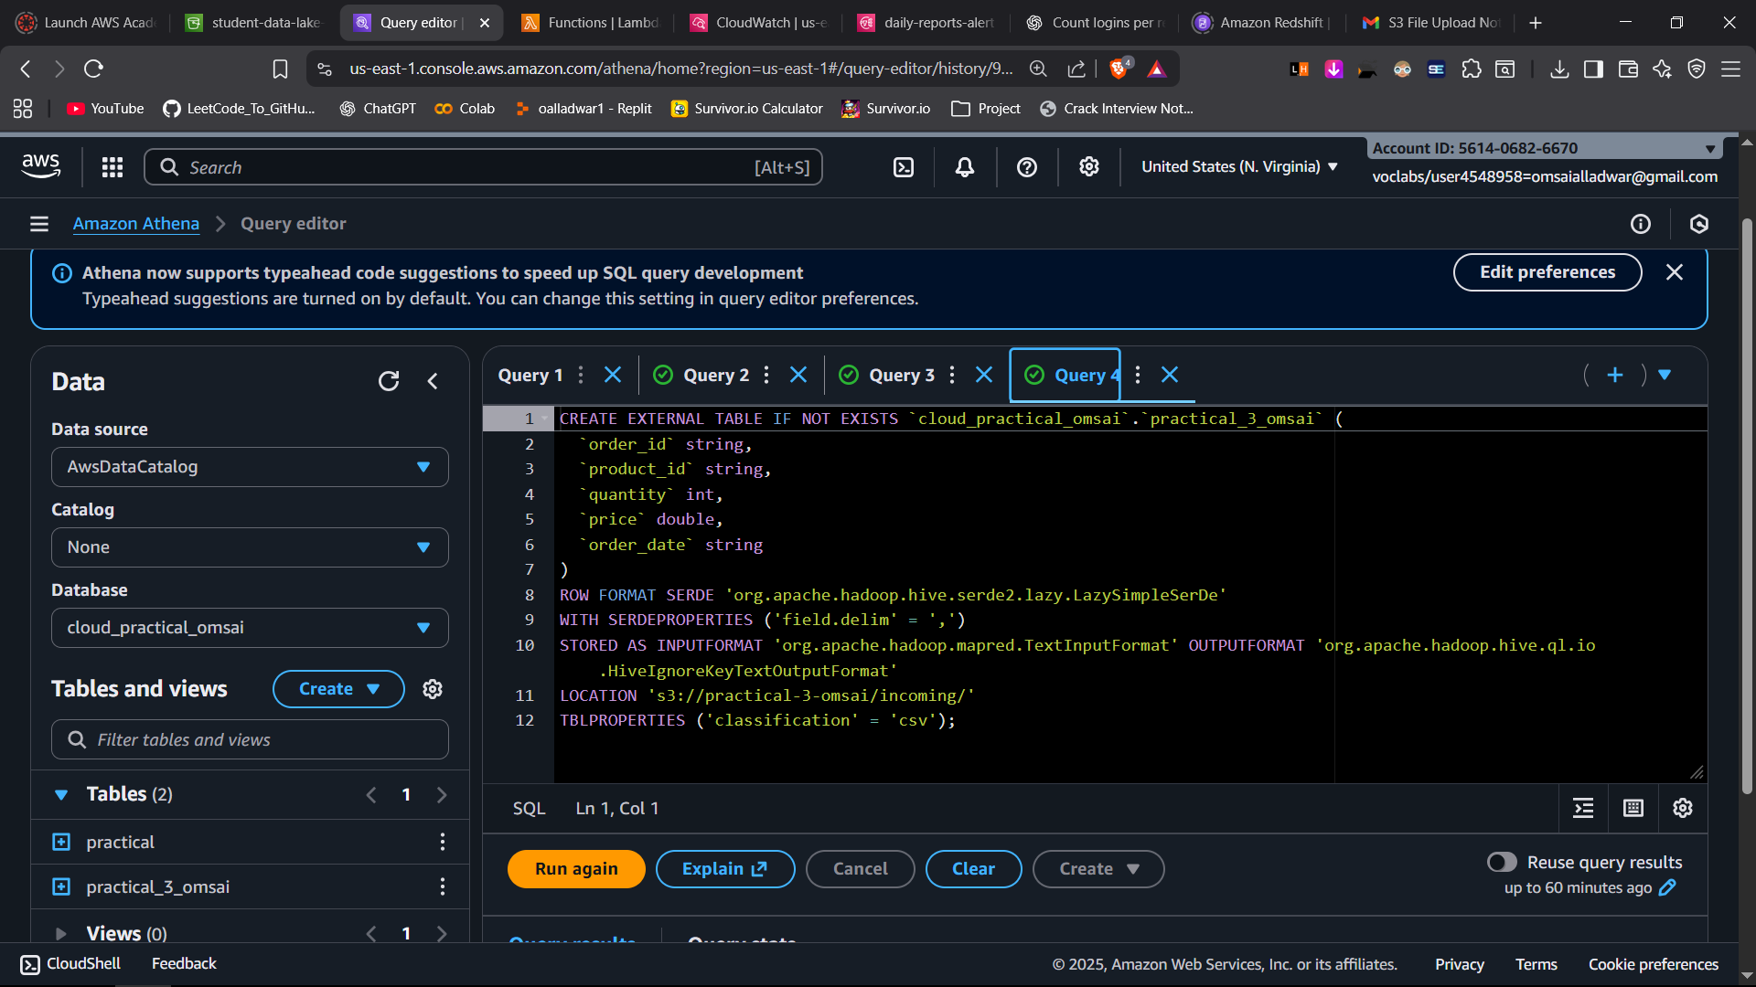

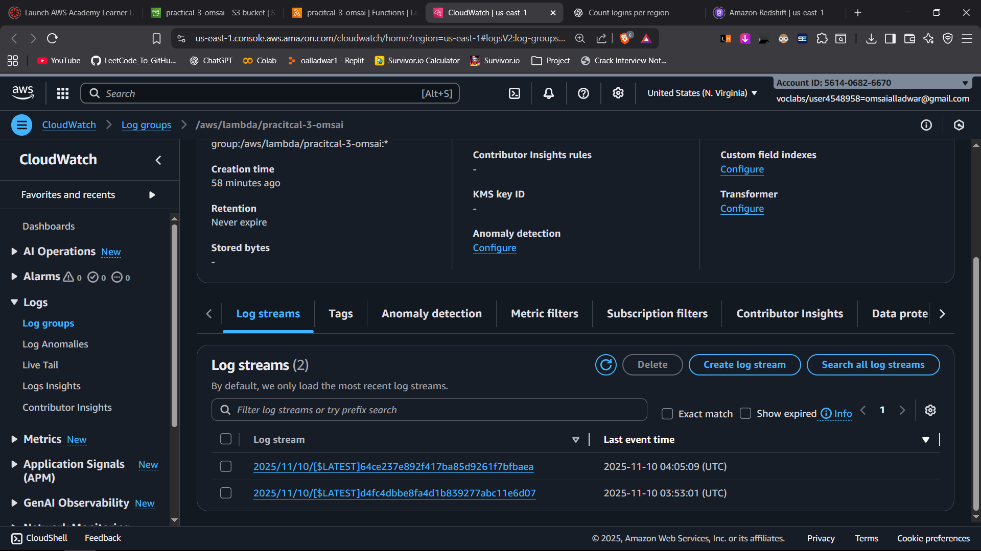
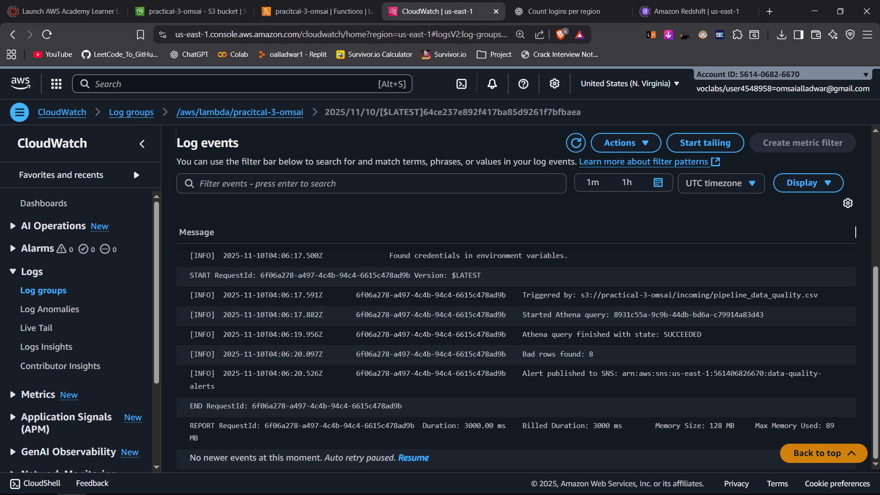
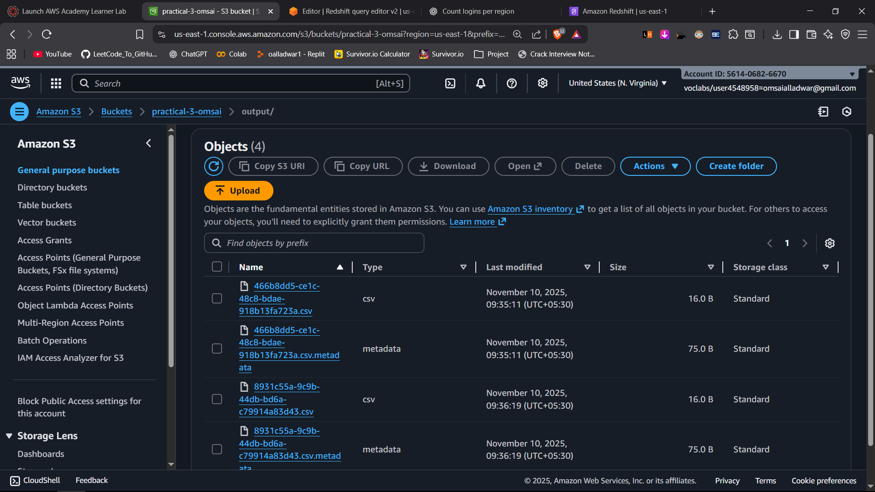
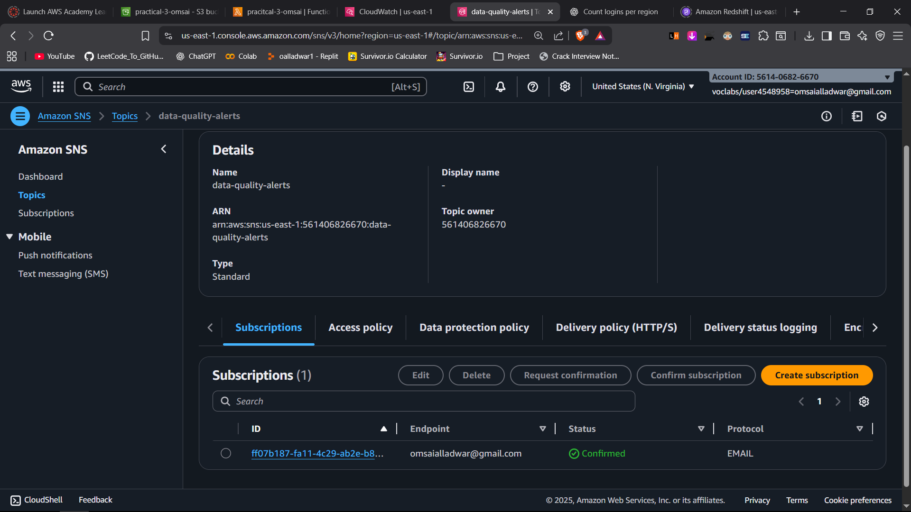
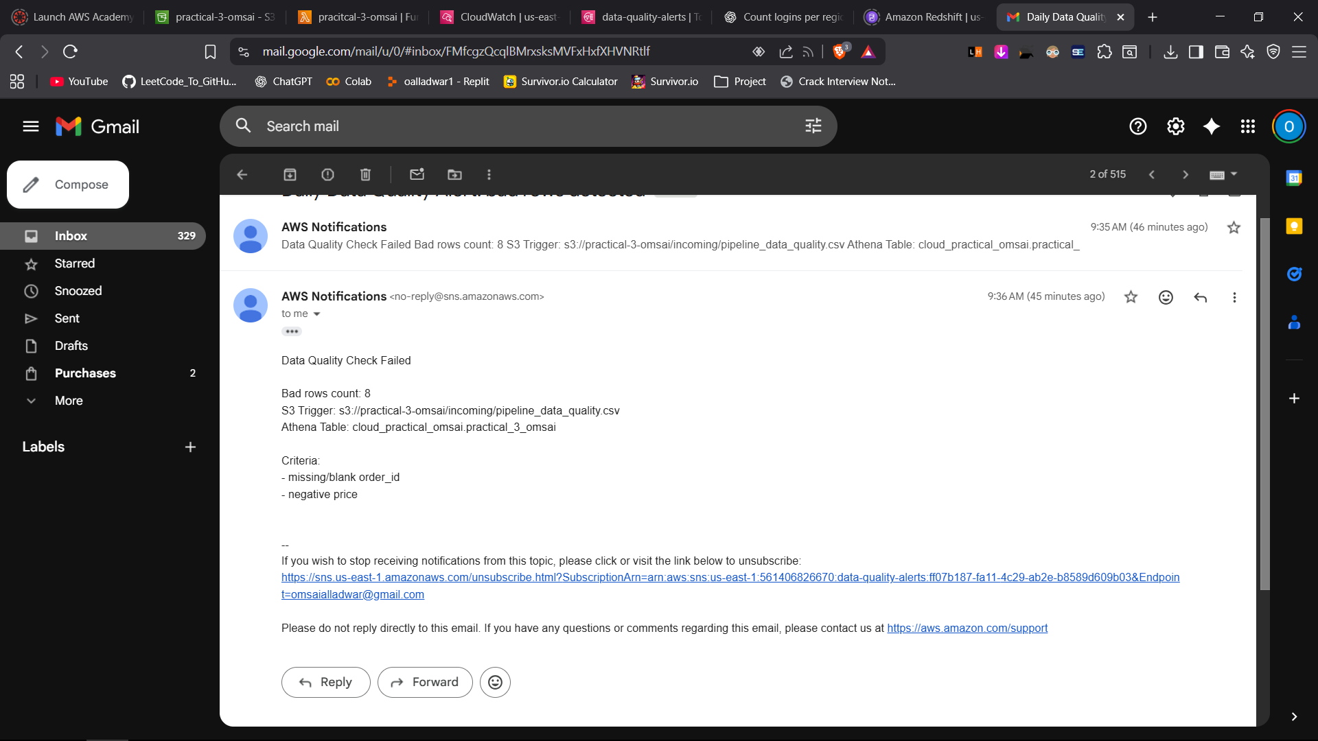

Results stored in practical 3 results.csv

